Digitective Game Design Document

### Content:

* Short description
* Story and Character
* Mechanics and Puzzles
* Progression and Mission System
* UI
* Tooling
* Audio

### Short description:

Digitective is a puzzle game based around cyber security and scam avoidance. It uses 2D text and logic based puzzles set within a 3D environment for additional immersion. The player slips into the role of a detective who specializes in scams and cybercrime, and then has to essentially find out which of his clients are being scammed, what ticked him off, and how the client can avoid this themselves.

### Story and Character:

The game is set in the current day, but the character Bram van der Loo likes the style of 1950s noir detectives, as he thinks that makes his boring desk job sound and feel cooler. For this reason he writes most of his notes with a typewriter, and used to smoke heavily for sheer coolness, before his current girlfriend asked him to stop. He also loves contemporary crime stories, and even got himself a leather jacket in order to mimic Albert Stegeman from the well known TV series “Undercover in Nederland”.

When he is not reading up on the latest trends in online fraud and cybersecurity for his work, he likes to read a lot of crime fiction, and usually has one or two cheap paperback novels close at hand, he likes to go hiking, as it gives him a way to get away from all the technology of his day to day, and he has the habit of chewing about a pack of gum per day, not only because it helps him deal with his nicotine withdrawal, but also because it masks the scent from his girlfriend when he does smoke the occasional cigarette in stress situations.

The game does not have a larger overarching plot, since it is made to be expanded by what are essentially content packs with the most up to date scams in the future. It does however has smaller evolving narratives with recurring characters, such as an older lady who is one of his first clients, and then noticeably gets more savvy with technology because of his help, until she sends him a proud email about how she helped one of her friends avoid a scam and how she is thankful to him for making her feel so competent.

### Mechanics and Puzzles:

The game uses 2 mechanics aside the puzzle gameplay.These two mechanics are the first person movement within the small detectives office, and the ability to inspect small objects in the environment (essentially pick them up, see them in more detail and rotatable to all sides with fixed view angles on those sides) are less relevant to gameplay, but serve to flesh out the experience. When the player inspects the detective's computer, they instead get put into the digital menu screen in the form of the web browser (see UI section), and if they inspect the detective’s notes folder on the desk, they get to the help menu (see UI section).

The game also has 3 types of puzzles:

* **Discrepancy Puzzles**: the player has to identify what is different from how it should be. Based on the difficulty of the puzzle, this can take the form of images, words/phrases or fonts. The player then needs to select these discrepancies correctly. (Similar to “Papers Please”)
* **Guided Conversations**: the player has to guide someone through a conversation with what they assume to be a scammer. The goal is to gather evidence of this assumption, and ultimately confront them with this evidence, hopefully scaring them away in the process. To do this, the player uses a branching dialogue system, as well as their own social intuition to navigate the conversation purposefully and effectively. Too many wrong choices here will essentially lead to a failstate of the given puzzle, but still a teachable moment for the player (for example: “oh no, they hung up. Well if it is legitimate, they will call again”).
* **Research and Analysis:** the player is confronted with a situation and a fake web-browser, they now need to look for context clues that will prove or disprove the legitimacy of a given offer. The scenario could for example be a suspiciously good deal on a shopping website, and the clues to investigate in that scenario would be the sellers account page, or a different website they might link you toward. This type of puzzle will combine elements from the first two types with some additional thinking.

### Progression and Mission System:

Whenever the player solves a case, they get rated by the amount of time spent on it, the accuracy and correctness of their findings, and the difficulty of the case. This will calculate their score, which will in turn increase the reputation of the detective agency. The higher a player's reputation, the more complex the cases which they will be offered. To ensure that the player can still progress at their own pace, the detectives email inbox will serve as a kind of mission select screen, where they can view a short summary of the cases backstory, and then have the option to work on it. These cases will always contain at least one of your current reputation-difficulty rating, as well as one above and one below so that the player has the option to decide on their desired level of challenge.

### UI:

The game uses three menus. The main menu uses the detectives filing cabinet as an interesting background for presenting options related to:

* audio (mirroring a menu also found in the ingame web browser, this offers volume sliders for the music, SFX and master)
* loading (this loads a previously saved game)
* (re)starting the game (this creates a new save game and starts the tutorial)
* closing the game (this quits the game)
* credits (this lists the games credits)
* further reading (this can be used to link to various external sources with additional information)
* language selection (this allows the player to switch between the various languages)

The second menu is the ingame web browser. This menu is stylized to look like a web browser, and serves as both the mission select screen for the puzzles, as well as the interface framework for the actual solutions of the puzzles. Using an organizational system similar to the tabs in a browser, the player is able to navigate between multiple currently open puzzles at will, or close ones they do not want to deal with (at which point the corresponding task in their email inbox would be updated to reflect their current progress).

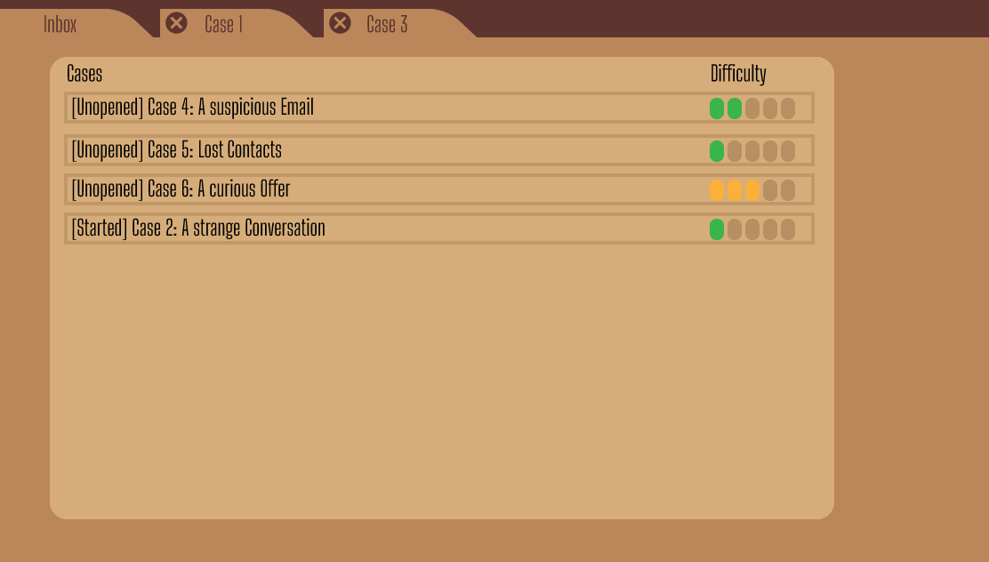

Fig1: ingame web browser and mission select screen

The third menu is the help menu. It is stylized as a folder of written notes from the detective to himself. It is sorted by categories of scam based on their medium, and then lists what to commonly look for when identifying them. This is meant to serve as a real life usable teaching tool, as well as a guidance for the puzzles where a player might get stuck otherwise (such as discrepancy tasks, or the more open research tasks). The content of these help pages should not be written on a case by case basis but more in regard to the templates used for scam creation.

These menus are intentionally designed with style and immersion first and ease of use second, since a lot of the players of this game are expected to have little to no experience with the medium of video games, and thus require an experience more closely based on the real world for them to feel at ease. It also helps with immersion which is proven to increase the learning effect.

### Tooling:

Since the game will rely on regular content updates in order to stay up to date and relevant, tooling for the mission creation is a very important aspect of the game. The goal with the tooling is that someone with a basic understanding of editor usage in Unity would not need to understand the functionality behind the scenes in order to create more missions based on the 3 mechanics types. The games systems should also be modular enough that someone with a basic understanding of Unity C# would be able to navigate the code and easily add new mechanics in order to expand the possible missions, without having to make too many structural changes along the way. This latter goal should be further helped by wide usage of comments that clearly explain what is happening where and how. Oops on that last part...

### Audio:

#### Sound effects:

Realistic and spatial where possible, shifting through menu pages should feel like flipping through a journal, printing out information for the case should have the sounds of whichever device it came out of. A source of inspiration for sound effects could be the game “Tearaway Unfolded.”

#### Music and ambient sounds:

**Background music**: Jazz noir, 1980s to 1990s era jazz music. Slightly more upbeat/not as gloomy as a detective brooding over his most recent cold case. As it won’t have any vocals it can’t be too monotonous and the BPM should be of >100.   
The objective will be to have three states of the main music that can fade along itself - a subdued version for menus and non-gameplay related tasks, a standard version that the player will hear regularly along gameplay, and a more active version for sequences wherein the player can fail.

**Ambient sounds**: Unless otherwise specified, it will mainly be rain clattering and running down windows.